# File-Server System

A COURSE PROJECT REPORT

By

**Divyansh Joshi (RA2011003011138)**

**Kankana Majumder (RA2011003011142)**

**Bhanu Pratap Singh (RA2011003011149)**

Under the guidance of   
**Rajalakshmi M***In partial fulfilment for the Course*

of

18CSC302J - COMPUTER NETWORKS

in C-Tech



**FACULTY OF ENGINEERING AND TECHNOLOGY SRM INSTITUTE OF SCIENCE AND TECHNOLOGY**

**Kattankulathur, Chenpalpattu District**

NOVEMBER 2022

**SRM INSTITUTE OF SCIENCE AND TECHNOLOGY**

**(Under Section 3 of UGC Act, 1956)**

**BONAFIDE CERTIFICATE**

Certified that this mini project report "**File-Server System**" is the bonafide work of **Divyansh Joshi (RA1911003010321), Kankana Majumder (RA2011003011142)** and **Bhanu Pratap Singh (RA2011003011149)** who carried out the project work under my supervision.

# SIGNATURE

**Rajalakshmi M**

# Assistant Professor

**Computer Networking**

SRM Institute of Science and Technology

# ABSTRACT

A program has to be designed for a small business organization. The organization hosts a File Transfer Server which is accessible to internet users using TCP/IP and FTP with IP address and Port number.

A network for the same was designed using Socket Programming. The requirements were emulated and tested for connectivity. A server was setup, which is accessible on port 1212 with HTTPS connectivity.

The client is connected to the server where it can upload files to the server and the other client of the organization will be able to download the required files.

# ACKNOWLEDGEMENT

We express our heartfelt thanks to our honorable **Vice Chancellor Dr. C. MUTHAMIZHCHELVAN**, for being the beacon in all our endeavors.

We would like to express my warmth of gratitude to our **Registrar Dr. S. Ponnusamy,** for his encouragement

We express our profound gratitude to our **Dean (College of Engineering and Technology) Dr. T. V.Gopal,** for bringing out novelty in all executions.

We would like to express my heartfelt thanks to Chairperson, School of Computing **Dr. Revathi Venkataraman,** for imparting confidence to complete my course project

We wish to express my sincere thanks to **Course Audit Professor Dr.Annapurani Panaiyappan, Professor and Head, Department of Networking and Communications** and **Course Coordinators** for their constant encouragement and support.

We are highly thankful to our my Course project Faculty **Rajalakshmi M ,** for his/herassistance, timely suggestion and guidance throughout the duration of this course project.

Finally, we thank our parents and friends near and dear ones who directly and indirectly contributed to the successful completion of our project. Above all, I thank the almighty for showering his blessings on me to complete my Course project.

**TABLE OF CONTENTS**

## CHAPTERS CONTENTS PAGE NO.

* + - 1. **ABSTRACT**
      2. **INTRODUCTION**
      3. **LITERATURE SURVEY**
      4. **Requirement Analysis**
      5. **ARCHITECTURE & DESIGN**
      6. **IMPLEMENTATION**
      7. **EXPERIMENT RESULTS & ANALYSIS**
         1. Server
         2. Client
         3. Client Connected
         4. Server Files
         5. Delete From Server
         6. Server and Client
      8. **REFERENCES**

1. **INTRODUCTION**
   1. **Scenario Description**

In this Project, we are trying to develop a File Server

System in Java to allow users/clients to download a file

from the server or upload a file into the server using

sockets.

This project is built with TCP/IP Socket Programming in Java. It can transfer

files among computers which are connected in the same network. It provides

user interface created with Java AWT and Java Swing. This java application

can transfer .txt, .xlsx, .pdf, image files, .mp4 and other video and audio format

files. The application shows the files and directories present in the server

working directory and allows the client to select files and download them in

the client system. It allows the client to upload files to the server working

directory. It also allows the server to delete files from the server working

directory.

Base Features:

● When the server system is loaded, it will initiate the required communication

setup so that clients can join in the system.

● When the client system is loaded, an option to provide the IP address/port

number of the server.

● A proper GUI with a directory service that can show the available directories and

files.

● A proper context-menu (a right-click mouse operation) for uploading a file in the

server.

● A proper context-menu (a right-click mouse operation) for downloading a file

from the server.

1. **LITERATURE SURVEY**

### **File server protocols and programs**

Several protocols are used in file servers. These offer different features and client accessibility.

**Server message block (**[**SMB**](https://www.techtarget.com/searchnetworking/definition/Server-Message-Block-Protocol)**)** is the most common protocol for LAN file servers. SMB is natively supported for Windows and macOS operating systems (OSes). Linux and Unix can access or serve SMB using [Samba](https://www.techtarget.com/whatis/definition/Samba) or CIFSD, an open source version of the [Common Internet File System](https://www.techtarget.com/searchstorage/definition/Common-Internet-File-System-CIFS).

SMB is simple to set up and administer. It can have integrated authentication with Microsoft [Active Directory](https://www.techtarget.com/searchwindowsserver/definition/Active-Directory).

SMB has had three major versions: SMB1, SMB2 and SMB3. SMB1 is no longer considered secure and should not be used.

**Network File System (**[**NFS**](https://www.techtarget.com/searchenterprisedesktop/definition/Network-File-System)**)** is primarily used by Linux and Unix OSes. It is, therefore, not common for end-user file servers but may be used for server file access.

**File Transfer Protocol (**[**FTP**](https://www.techtarget.com/searchnetworking/definition/File-Transfer-Protocol-FTP)**)** and **Secure FTP (**[**SFTP**](https://searchcompliance.techtarget.com/definition/SFTP-Secure-File-Transfer-Protocol)**)** are designed to serve files over the internet. FTP is generally used to download and upload files; it is not designed for clients to execute the data from the remote file system directly. Some examples of FTP server software are [FileZilla](https://www.techtarget.com/whatis/definition/FileZilla) and Microsoft [Internet Information Services](https://www.techtarget.com/searchwindowsserver/definition/IIS).

1. **Experiment Result and Analysis**

**7.1 Client**

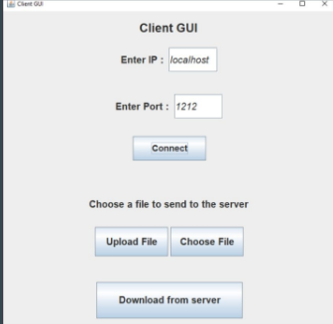

**7.2Server**

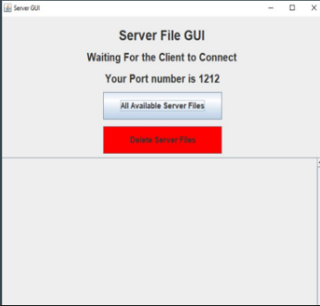

**7.3 Client Connected**

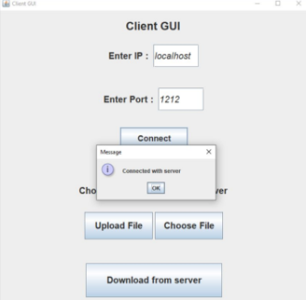

* 1. **Server Files**

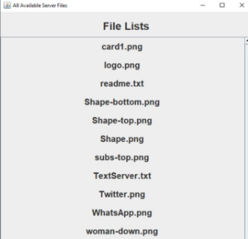

* 1. **Delete From Server**

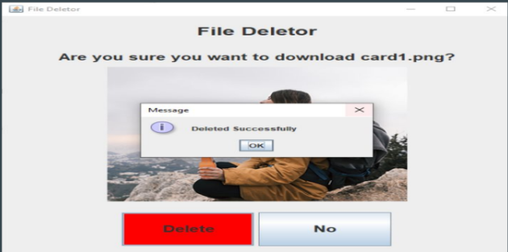

* 1. **Server and Client (Downloaded From Server)**

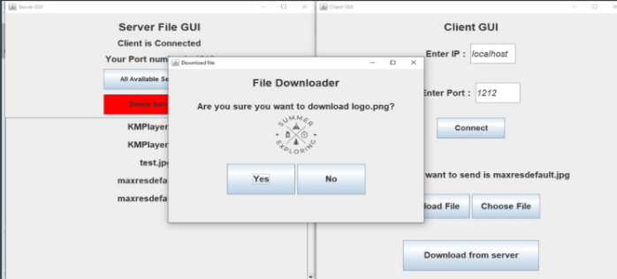

**5. ARCHITECTURE & DESIGN**

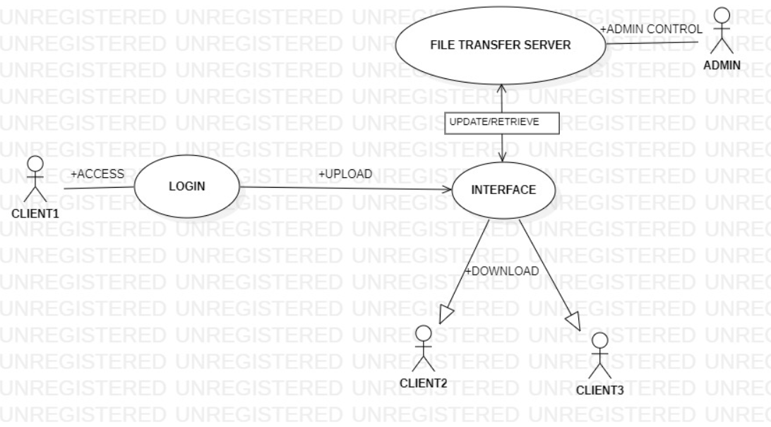

**6. IMPLEMENTATION**

**6.1 Server:**

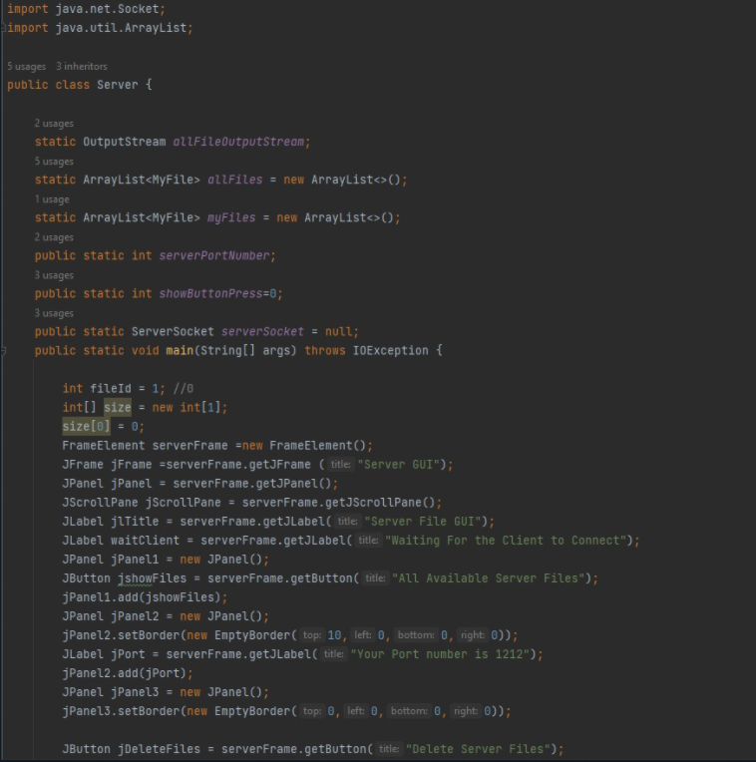

**6.2 Client:**

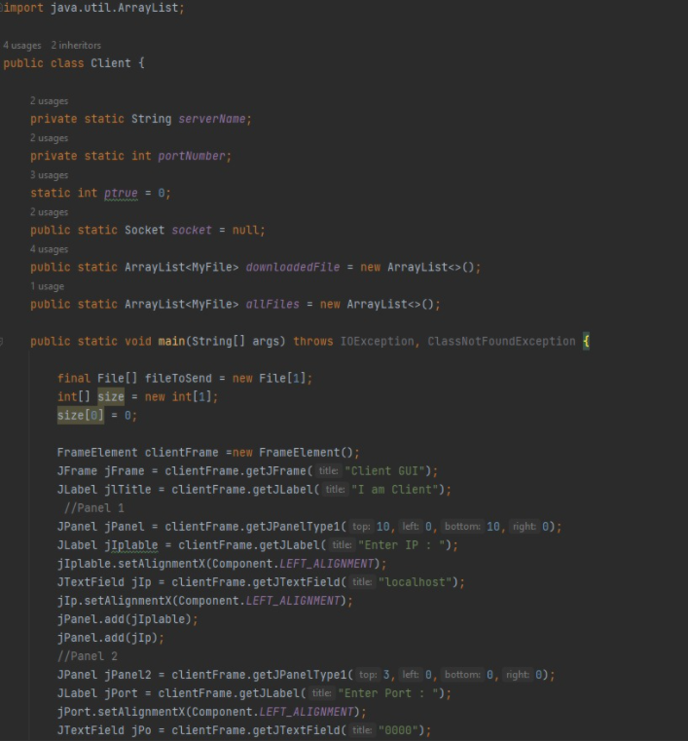

**4. Requirement Analysis**

Hardware Requirements:

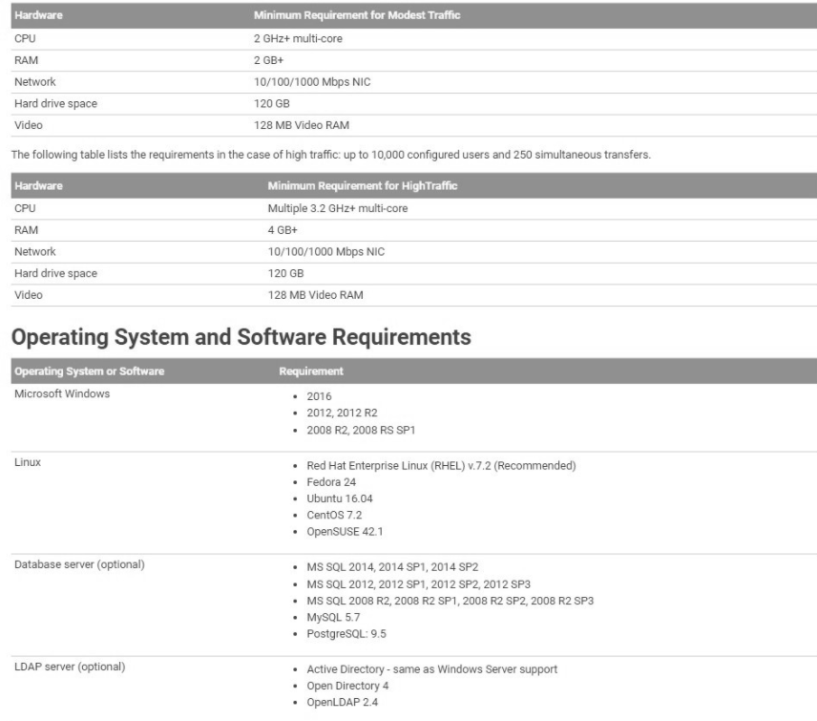

**REFERENCES**

1. TCP/IP Protocol Suite by Behrouz A. Forouzan
2. Google
3. Wikipedia
4. GitHub